1 February 2016
New exhibition celebrating generous donations to the Museum of the History of Science

New Acquisitions, opening 19 January 2016 at the Museum of the History of Science, is a new entrance gallery exhibition celebrating recent arrivals to the Museum. Included are an unusual medieval European astrolabe and a collection of scientific instruments from the 18th and 19th century, which have been given in two separate, generous donations.
The astrolabe, acquired at an auction in 2014, was given anonymously to the Museum and will be added to the existing collection of astrolabes, which is the largest and most important in the world.
Astrolabes are ancient devices which capture the apparent movements of the sun and stars in the sky. They were used in astronomy, time-telling, astrology and religion across cultures, time and places. The donated astrolabe includes a universal plate for use anywhere on Earth which provides important new evidence of the transmission of advanced medieval Islamic innovations to Europe in the 15th century. It is also an example of a medieval device that has been adapted and reworked in the 16th century, telling a story of the Renaissance recycling rather than rejecting the Middle Ages.
The second recent donation was kindly given by Mr H. R. Bristow, a retired engineer and divisional manager with the Elliott Brothers company (later part of BAE Systems). Elliott Brothers was an innovative British firm founded in the mid-19th century, producing instruments for navigation, surveying, calculating, telegraphy, optics, and mechanical and electrical engineering. Its work included significant output for the Admiralty of the Royal Navy.
The Museum already holds material from the company in its Elliot Collection, but Mr Bristow’s items focus on the early beginnings of the business and include late 18th-century work made by William Elliott, father to Frederick Henry Elliott and Charles Alfred Elliott, who later founded Elliott Brothers.
“I always had in mind that the examples I had found should remain as a single collection and I am very pleased that the Museum of the History of Science is able to accept it in a safe and accessible way, where it will complement the company collection of later material,” says Mr Bristow.
Both the astrolabe and a selection of items from the Bristow Collection are now on display in the Museum’s entrance gallery exhibition New Acquisitions. Also featured in the exhibition is a beautiful English mathematical aide-mémoire from c.1665, which has been purchased with support from the Art Council’s PRISM fund and an anonymous benefactor, and a remarkable Portable Museum of Raw Materials and Manufactures, from mid-19th century England, which was purchased with the aid of an anonymous donor.
New Acquisitions is supported by evening lectures, which can be booked for free through the Museum’s Eventbrite page at www.bit.ly/mhs-events.

EVENTS:
Recycling the Astrolabe
Tuesday 8 March, 7pm
To mark the acquisition of a new and important astrolabe in the collection, Dr Stephen Johnston (MHS) and Dr Koenraad van Cleempoel (Hasselt University, Belgium) present the first research results on its story. The Museum's new acquisition is an example of a medieval device that has been adapted and reworked in the 16th century: it tells a story of the Renaissance recycling rather than rejecting the Middle Ages.
For further information and images contact:
Robyn Haggard
Public Engagement Officer
01865 287406
robyn.haggard@mhs.ox.ac.uk

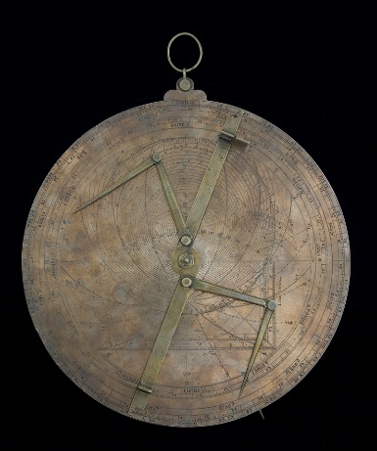
Aide-mémoire from the c.1665 purchased with support from the Art Council’s PRISM fund and a generous donor (inv. 14977)
Single Plate Universal Astrolabe (inv. 14645)
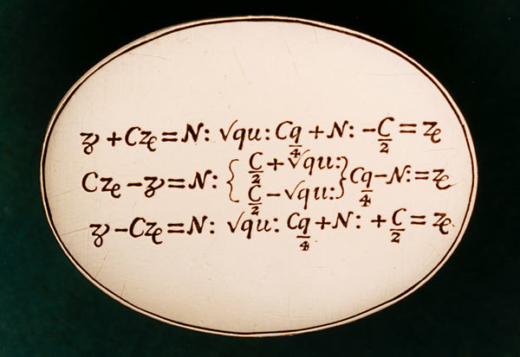
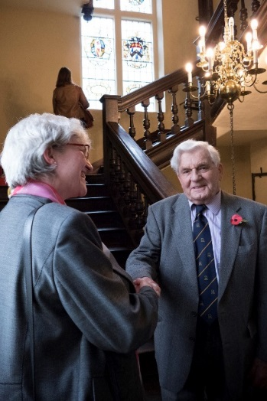
Mr Ron Bristow with Museum director Dr Silke Ackermann

************
Notes to Editors
About the Museum of the History of Science
MHS houses an unrivalled collection of early scientific instruments in the world’s oldest surviving purpose-built museum building, the Old Ashmolean on Broad Street, Oxford. The Museum is a research and teaching department of the University of Oxford, offering free access to its permanent displays and a programme of special exhibitions, family-friendly events, talks and tours, along with taught sessions for schools.
www.mhs.ox.ac.uk
insidemhsoxford.com
Instagram and Twitter: @MHSOxford

